**CSS PRACTISE**

**Do not use the table, use the properties of CSS to create Web pages that has the below content. File format has a name as Style.CSS**

**Lesson 1:**

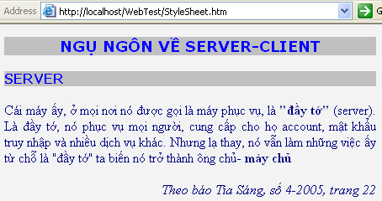

**Lesson 2**:

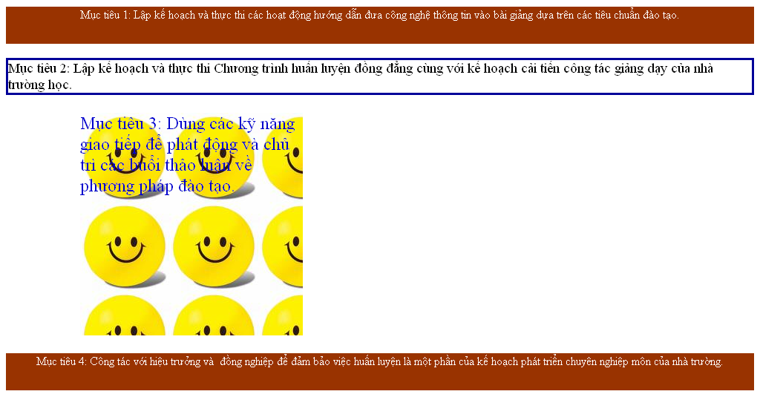

**Lesson 3:**



**Lesson 4:*****Create effects for underlined links***

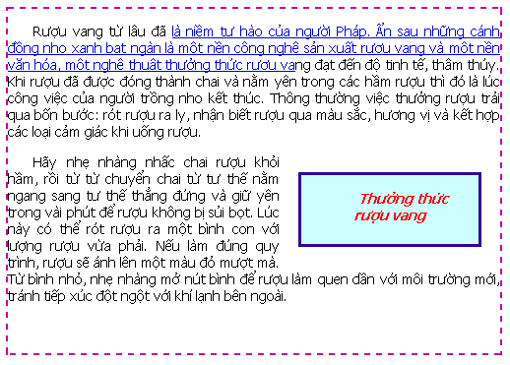

**Lesson 5:** *Create the colums*

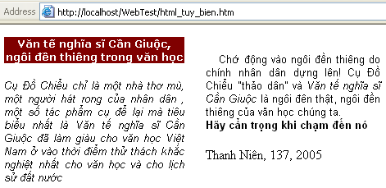

**Lesson 6:** *Use CSS in creating Web page layout as below:*

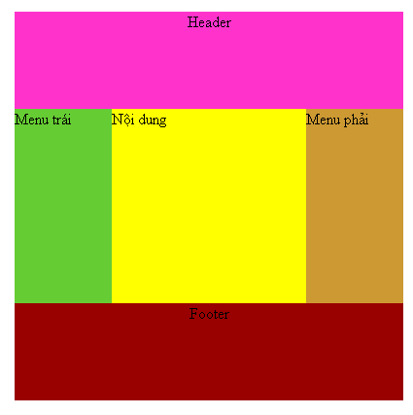

**Lesson 7:** *Use CSS to create Menu*

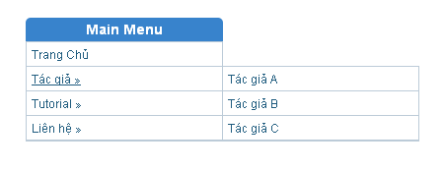

*Step 1*: Create File Style.CSS:

**\* {margin: 0; padding: 0}**

**div#wraper {**

**width: 500px;**

**margin: 40px auto;**

**line-height: 2em;**

**font-family: helvetica, arial, tahoma;**

**font-size: 12px;**

**}**

**div#mainNav {**

**width: 200px;**

**}**

**div#mainNav h1 {**

**font-size: 14px;**

**background: #3883cc;**

**color: white;**

**text-align: center;**

**-moz-border-radius: 5px 5px 0px 0px;**

**}**

**div#mainNav ul {**

**list-style: none;**

**border: 1px solid #bccbd8;**

**}**

**div#mainNav ul li {**

**position: relative;**

**border-bottom: 1px solid #bccbd8;**

**}**

**div#mainNav ul li a {**

**color: #1e5b7e;**

**text-decoration: none;**

**padding: 5px;**

**}**

**div#mainNav ul li a:hover {**

**text-decoration: underline;**

**}**

**div#mainNav ul li ul {**

**position: absolute;**

**top: -1px;**

**left: 198px;**

**display: none;**

**}**

**div#mainNav ul li:hover ul {**

**display: block;**

**width: 100%;**

**}**

*Step 2*: Create File HTML link to File CSS

**<div id="wraper">**

**<div id="mainNav">**

**<h1>Main Menu</h1>**

**<ul id="nav">**

**<li><a href="#">Trang Chủ</a></li>**

**<li><a href="#">Tác giả &raquo;</a>**

**<ul>**

**<li><a href="#">Tác giả A</a></li>**

**<li><a href="#">Tác giả B</a></li>**

**<li><a href="#">Tác giả C</a></li>**

**</ul>**

**</li>**

**<li><a href="#">Tutorial &raquo;</a>**

**<ul>**

**<li><a href="#">Web Design</a></li>**

**<li><a href="#">Photoshop</a></li>**

**<li><a href="#">Hosting</a></li>**

**<li><a href="#">Domain Names</a></li>**

**<li><a href="#">CSS</a></li>**

**</ul>**

**</li>**

**<li><a href="#">Liên hệ &raquo;</a>**

**<ul>**

**<li><a href="#">Demon Warlock</a></li>**

**<li><a href="#">Frost Mage</a></li>**

**<li><a href="#">Descipline Priest</a></li>**

**<li><a href="#">Furry Warrior</a></li>**

**</ul>**

**</li>**

**</ul>**

**</div>**